SOP – Dept of Animal Biosciences
  - Gas Tank Use

If you are a gas tank user, please follow the instructions below:
- Contact Julie Kim (jungmi@uoguelph.ca) to schedule training for the safe and proper use of gas tanks
- Common gas stock is located in room 176 (Helium, Nitrogen, Air, Carbon Dioxide, Oxygen, Compressed Air).
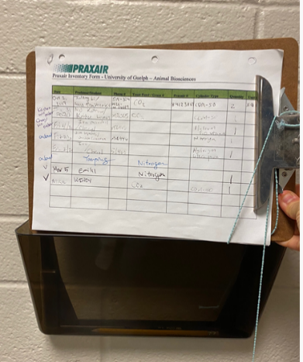
- When you take a tank, fill out the form beside room 253 (see photo below) or email Julie Kim the catalogue # of the tank you took (eg. for medical oxygen, OX M-K note there are different kinds). You can ignore the name on the tag.
- Julie will then order the replacement which ensures we will always have consistent stock
- If you require special gas, please contact Julie.

